# OrientExpress EuAuAs EASY-1322

22/03/2024

Siobhan Tobin & Andrew Wildes

## Summary

Space group = *P63/mmc,* Lattice param *a* = 4.41 ang, *c* = 8.28 ang nominal

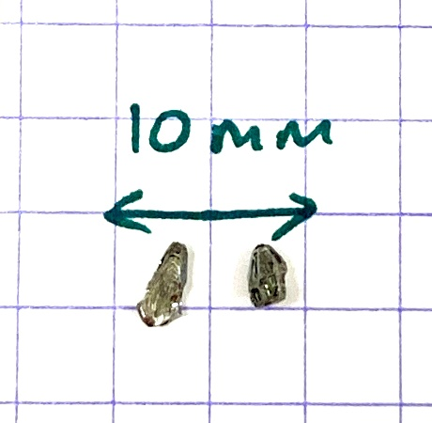 Sample 1 = Flatter “Triangle” sample on the left. Sample 2 on the right.

Orientation 1 –> 90 deg -> Orientation 2 –> 90 deg -> Orientation 3

|  |  |  |  |  |
| --- | --- | --- | --- | --- |
| Run number | Sample – detector distance (mm) | Exposure time  (min) | Sample | Note |
| 7377 | 51.16 | 2 | 1 |  |
| 7378 | 51.16 | 5 | 1 |  |
| 7379 | 41.17 | 10 | 1 | Orientation 1 |
| 7380 | 41.17 | 10 | 1 | Orientation 2 |
| 7381 | 41.17 | 10 | 1 | Orientation 3 |
| 7382 | 41.17 | 5 | 2 |  |
| 7383 | 41.17 | 10 | 2 | Orientation 1 |
| 7384 | 41.17 | 10 | 2 | Orientation 2 |
| 7385 | 41.17 | 10 | 2 | Orientation 3 |

## Sample 1

|  |  |
| --- | --- |
| Sample 1, orientation 1, photo of face that was in beam | Sample 1, orientation 1, run 7379 |
| Sample 1, orientation 2, photo of face that was in beam | Sample 1, orientation 2, run 7380 |
| Sample 1, orientation 3, photo of face that was in beam | Sample 1, orientation 3, run 7381 |

## Sample 2

|  |  |
| --- | --- |
| Sample 2, orientation 1, photo of face that was in beam | Sample 2, orientation 1, run 7383 |
| Sample 2, orientation 2, photo of face that was in beam | Sample 2, orientation 2, run 7384    Looks like there was some plasticine in the way here |
| Orientation 3 = 180 deg rotation from orientation 1 | Sample 2, orientation 3, run 7385    Looks like there was some plasticine in the way here |